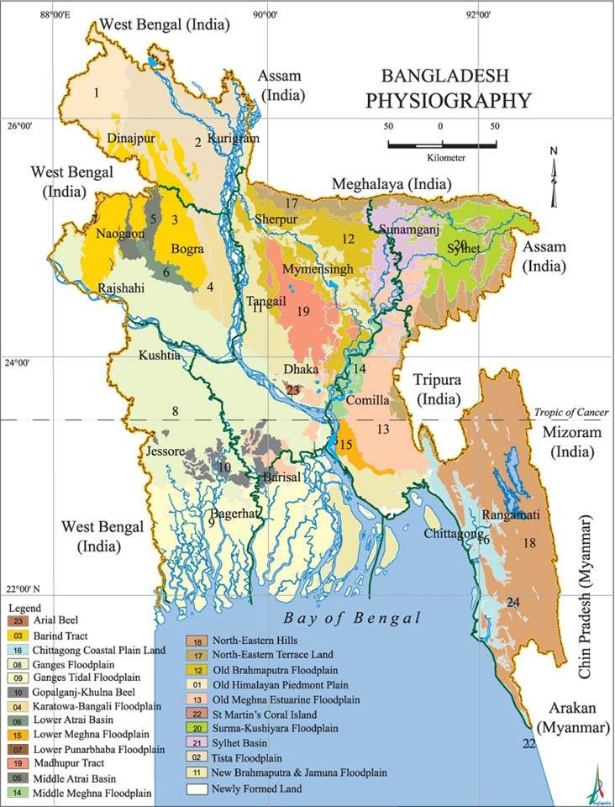

**Bangladesh: A Nation State Born in 1971**

## Total Area: 56,977 sq. miles

(1,47,570 sq. k.ms.)

*The limits of territorial water area of Bangladesh are 12 nautical miles and the area of the high seas extending to 200 nautical miles measured from the base lines constitutes the economic zone of the country.

*(Statistical Year Book Bangladesh* confirm in 2020 *Statistical Year Book Bangladesh 2020*, Bangladesh Bureau of Statistics (BBS), Dhaka: Ministry of Planning, Government of Peoples Republic of Bangladesh, May 2021, 4th edition.)

Sixth Population and Housing Census

Bangladesh Bureau of Statistics, June, 2022.

* The population of the country was 169.83 million in 2022.
* The male population is 84.08 million and female is

85.65 million.

* The average annual growth rate of the population was

1.22 per annum.

* The density of population was 976 per sq.km. in 2011 which increased to 1119 per sq.km. in 2022.
* The total number of households is 41,010,051 which is distributed as 27,820,341 in rural areas and 13,189,710 in urban areas.

## Culture

* Denotes a wide range of meaning
* It has been used in different disciplines
* It is a term that includes our believes, norms, way of life, language, system of communication
* It includes the materials objects used by a particular group or society.
* Performing arts like dance, drama, movie or storytelling, folk art, literatures are also included in Culture.

# Culture

* UNESCO defines culture as the set of distinctive spiritual, material, intellectual and emotional features of society or a social group, that encompasses, not only art and literature, but lifestyles, ways of living together, value systems, traditions and beliefs*.*

*(UNESCO Universal Declaration on Cultural Diversity, 2001)*

* Whereas it is not always possible to measure such beliefs and values directly, it is possible to measure associated behaviours and practices

(*The 2009 UNESCO Framework for Cultural Statistics,* page 9)

Lecture 2

**Geographical Features of Bangladesh**

* + Location
  + Physiographic units (Land formation)
  + Climate
  + River system
  + Bay of Bengal and the Sundarbans
  + Influence of Geography in history, economy and culture

**For introductory reading please follow the**

[h**l**t**i**t**n**p**k**s://en.banglapedia.org/index.php?title=Bangladesh_Geography](https://en.banglapedia.org/index.php?title=Bangladesh_Geography)

## Bengal (pre-1947 phase)

* Here it means the geographical identity in colonial times (1765-1947)
* comprising the area of present Bangladesh and the Indian province of *Paschim Banga* (West Bengal)
* It often expanded to neighboring areas- Assam, Meghalaya, Tripura, Bihar, Orissa and sometimes up to Delhi

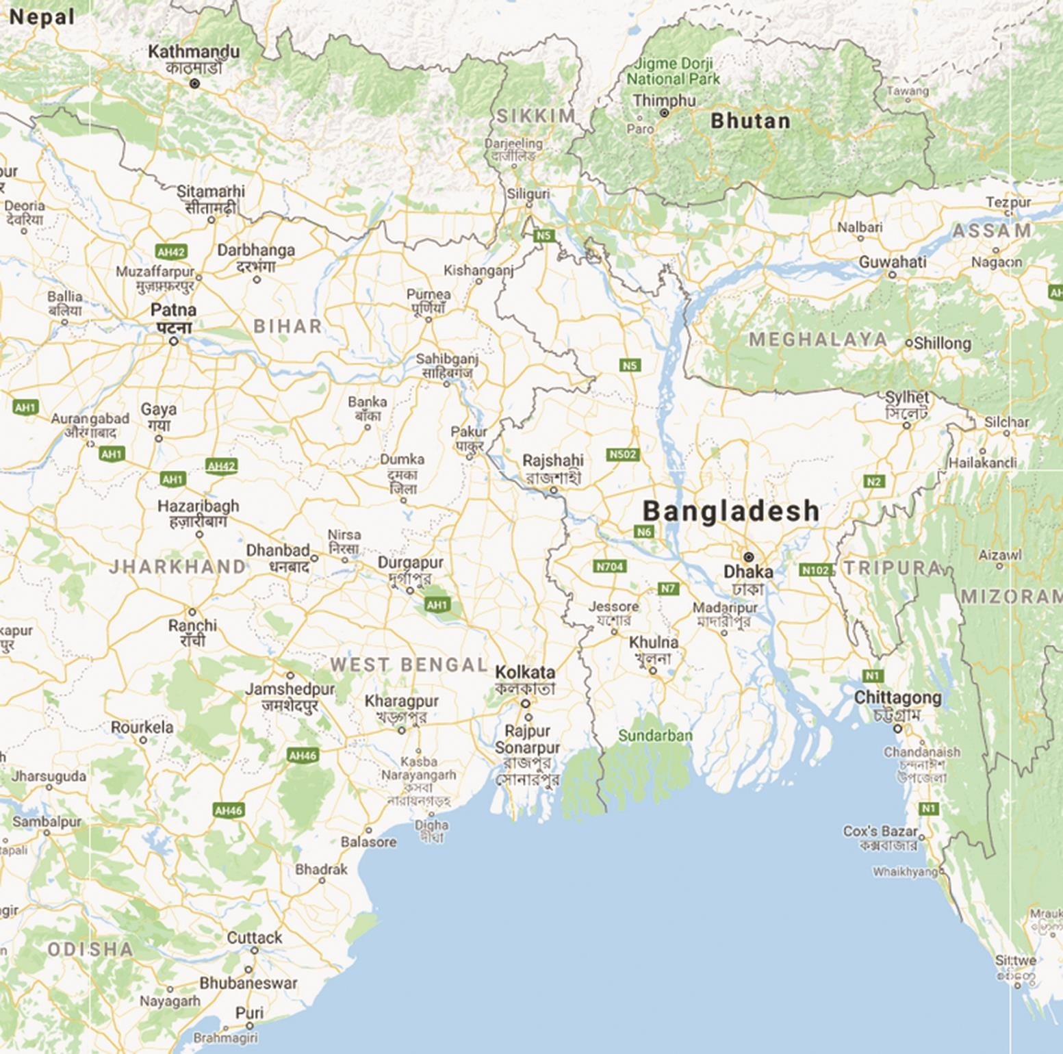

## Location: Bangladesh

* Bangladesh is located in South Asia
* At the south east corner of the Indian Subcontinent
* Bordered by the Indian States in three sides
  + West Bengal, Assam, Meghalaya, Tripura
  + It has border with Myanmar in the south-eastern side
* The Bay of Bengal in the south

**For further reading please follow the link**

<https://en.banglapedia.org/index.php?title=Bangladesh_Geography>

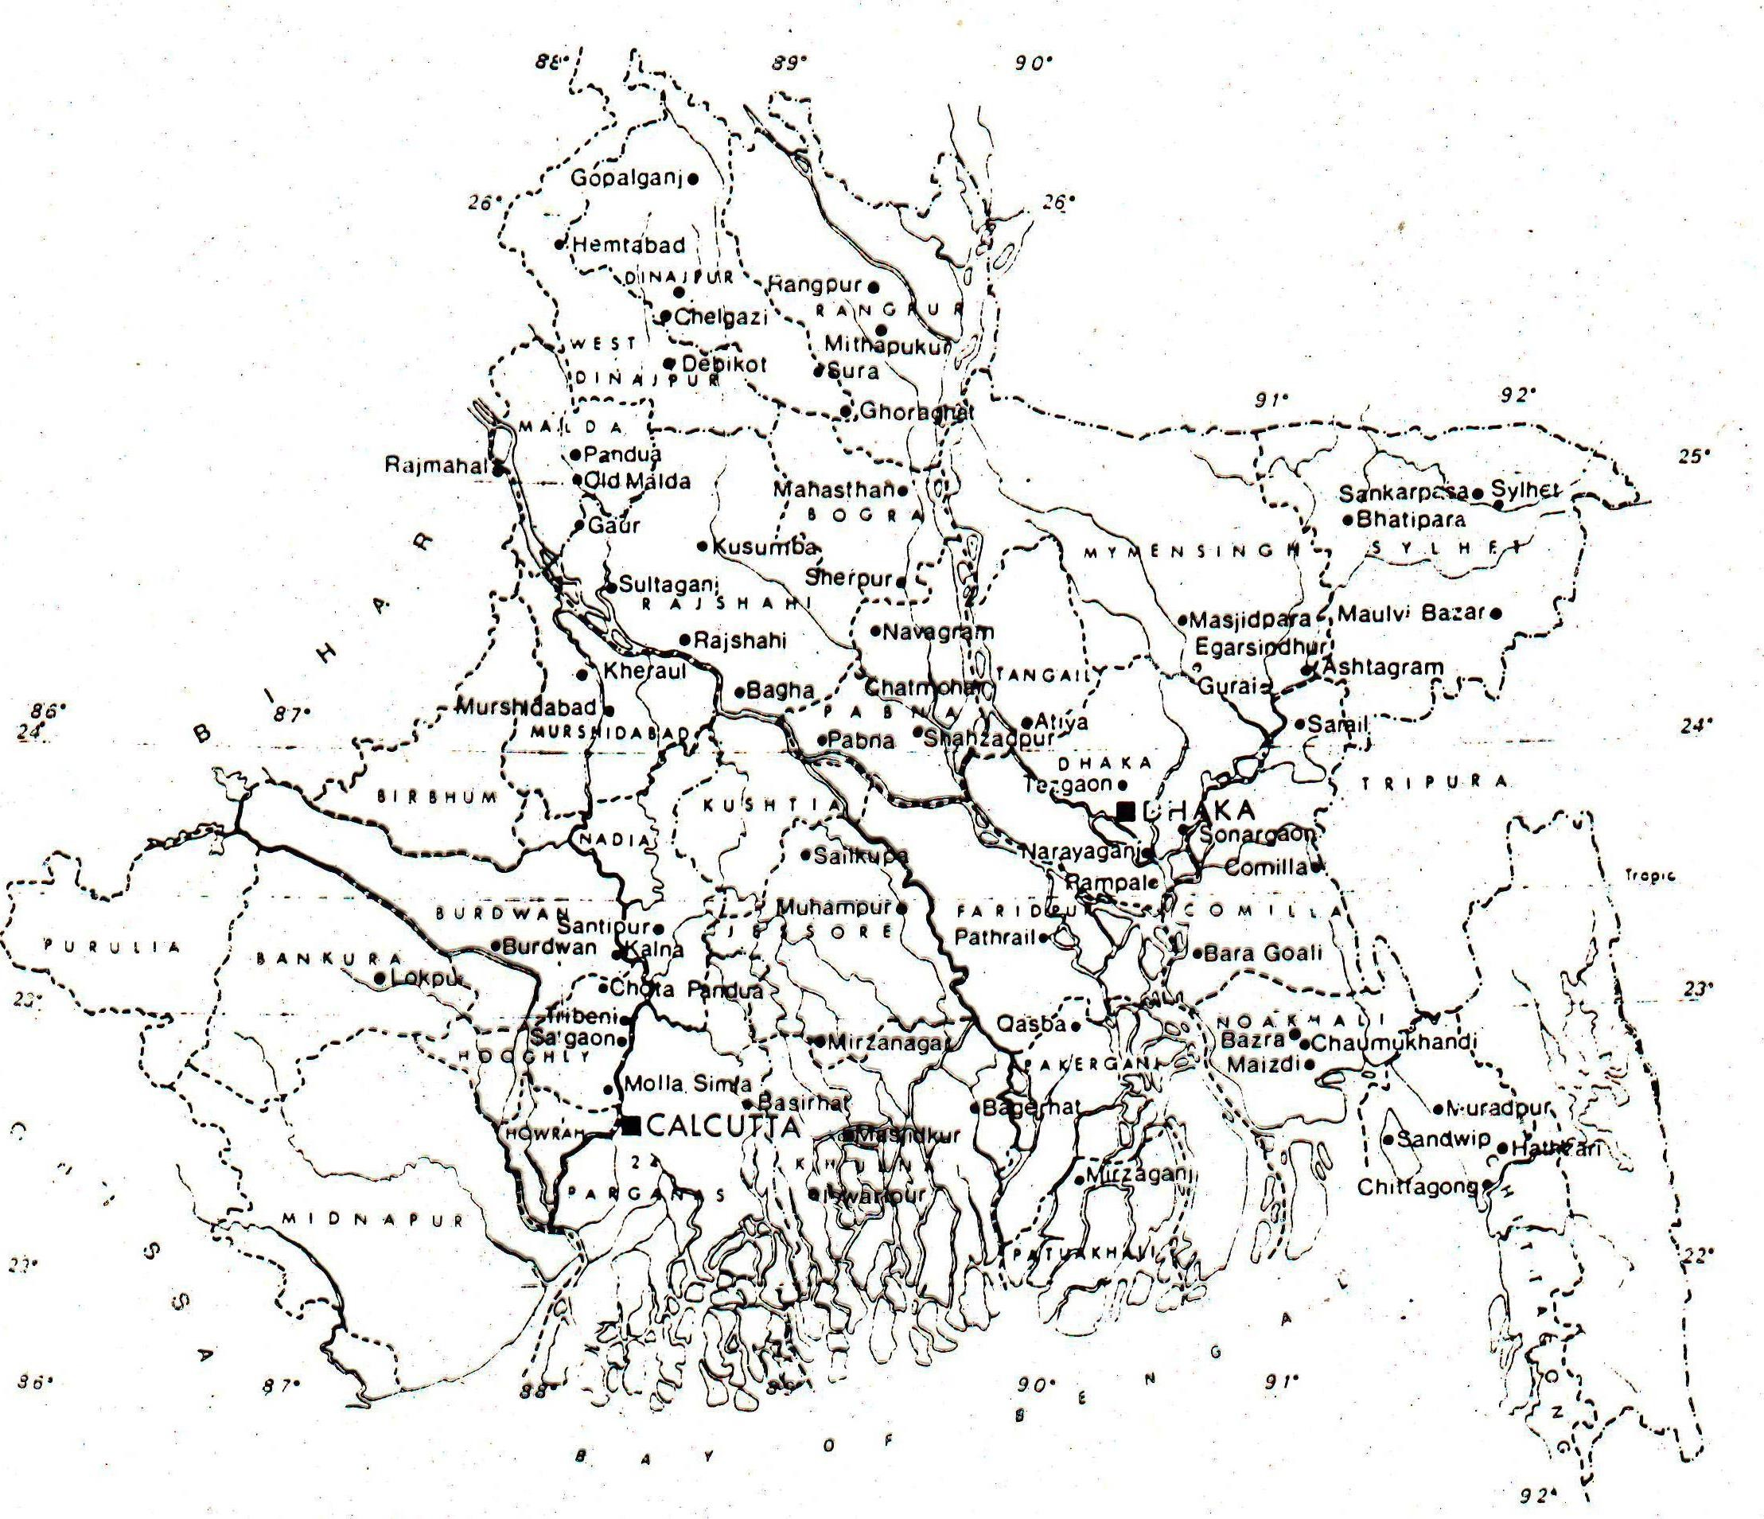

### Bengal during Pre-1947

* It will be very difficult to quantify the extant of Bengal with modern measurement units.
* The first attempt to figure it was done by the British Government in 1872 CE, when the first census was done.
* Bengal was measured 94,539 sqm
* Situated between 27°9ʺ and 20°50ʺ north latitude and 86°35ʺ and 92°30ʺ east longitude.

## Location: Bangladesh

* Bangladesh is located in South Asia
* At the South east corner of the Indian Subcontinent
* Bordered by the Indian States in three sides
  + West Bengal, Assam, Meghalaya, Tripura
  + It has border with Myanmar in the south-eastern side
* Bay of Bengal in the south

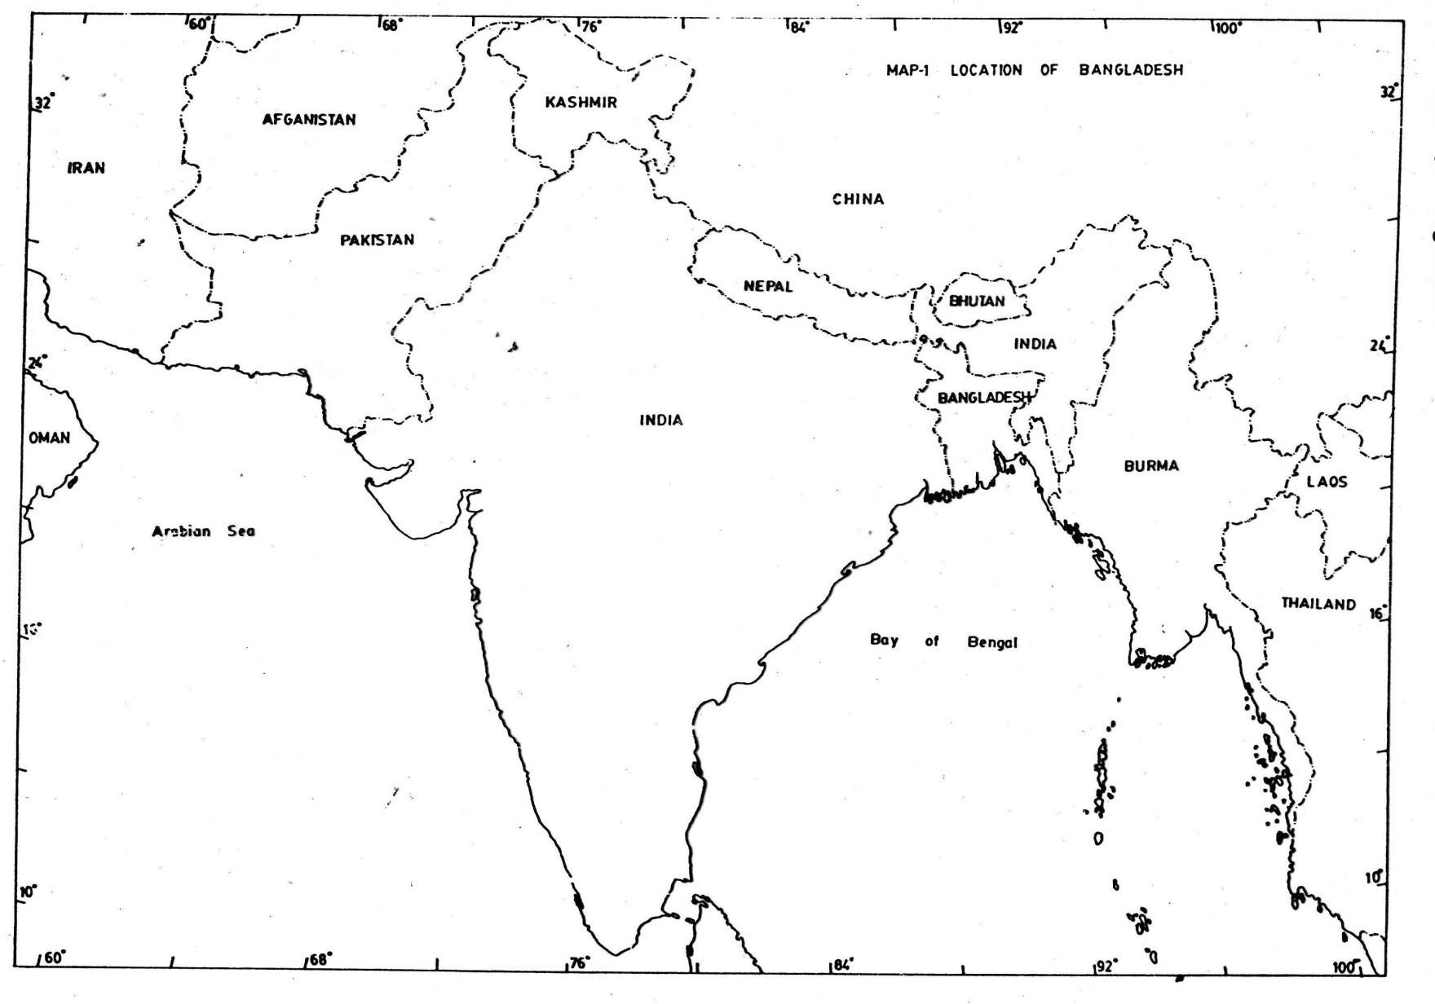Bengal’s Location in the Subcontinent

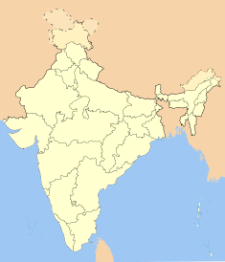

The Himalayas and other hills

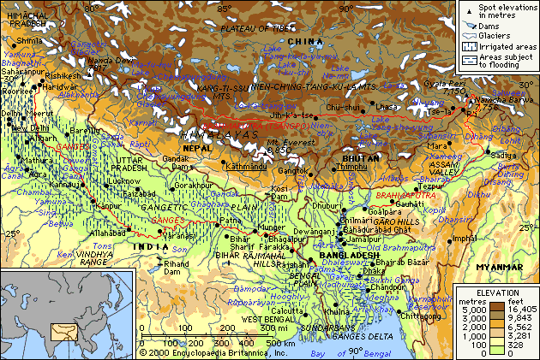

## Location and Natural boundary

* Located at the southern corner of the Indian Subcontinent
* the Himalayan hills on the north
* The eastern border: the Garo-Khasi-Jaintia hills in the northern side and Chittagong-Arakan hills in the southern side.
* The mangrove forest of the Sundarbans stands as a transit zone between the sea and the land in the southwestern part.

Physiographic units Land formation

* + It is difficult to find out how and exactly when this region came into existence and acquired very distinct geo-physical features.
  + There is a good deal of physiographic variety within the general pattern of geological setting of the ‘Bengal Delta’.

Physiographic units of Bangladesh



<https://en.banglapedia.org/index.php/Physiography>

**the Bengal Delta can be classified into three sections**

* **Moribund Delta:** It stretched over the then districts of Nadia, Jessore and Murshidabad, ‘the northeastern quadrilateral’ was surrounded by Bhagirathi-Padma-Madhumati in the north and eastern side. Northern boundaries of Khulna and 24 Parganas have created a rough line along the southern border.
* **Mature Delta:** This is a land strip between the Moribund and the active part of the delta spreading over the northern half of 24 Parganas and Khulna districts. Here the rivers are quite dynamic and ‘some salinity occurs along with the larger one’.
* **Active Delta:** The active part of the delta consists of the largest mangrove forest, the Sundarbans, and the land mass between the river Madhumati and Meghna.

**For further reading please follow the link**

<https://en.banglapedia.org/index.php?title=Bengal_Delta>

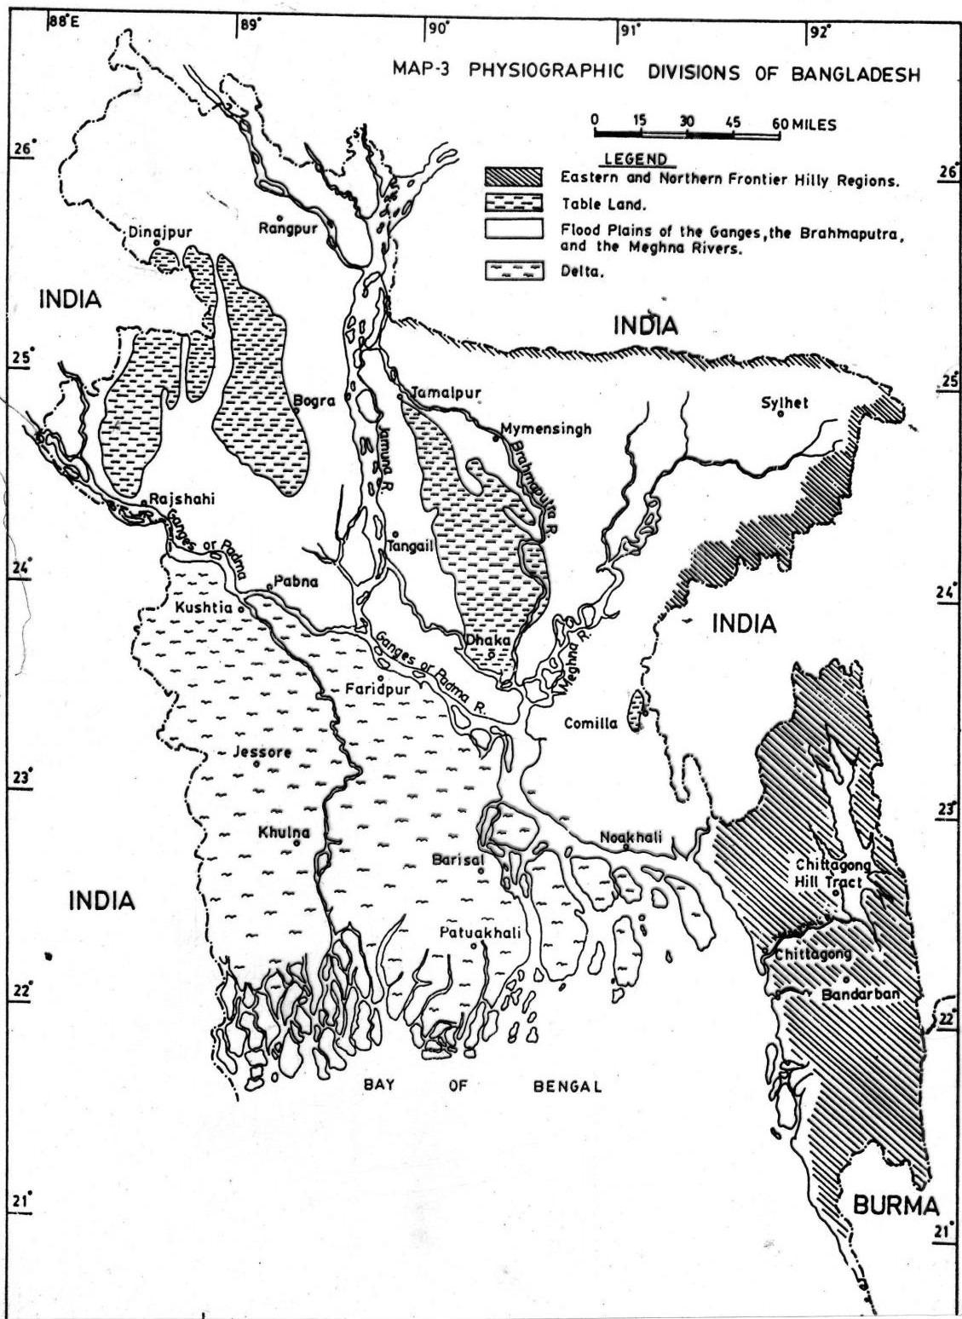

Old Alluvium Land Tracts:

(West Bengal)

* + A large area of old alluvial land in the middle, eastern,

northern and western parts of ‘Bengal’.

* + In the west, the old alluvial tract extends from the south of Rajmahal almost to the sea.
  + The deep forests and the mountainous regions of the Rajmahal, the Saontal Parganas, Manbhum-Singbhum-Dhalbhum comprise this old alluvial land.
  + East of it are the higher red lands of the western parts of the districts of Murshidabad, Birbhum, Bardhaman, Bankura and Medinipur.
  + This plateau is quite hilly, woody, dry and infertile and

highland

* + Some parts of Raniganj and Asansol, Medinipur, and the
* A particular tract of this old land crosses the Ganga, north of Rajmahal and extends up to North Bengal. This belt of red soil and older rock cuts through the Malda-Rajshahi-Dinajpur-Rangpur area across the Brahmaputra and extends up to the hilly areas of Assam.
* Barind Tract: The comparatively high lands of Bog ra, northern portion of Rajshahi, eastern part of Dinajpur and western tracts of Rangpur
* Madhupurgarh, north of Dhaka, also belong to this old alluvium which is lacerated from the northern alluvial tract of Varendra by the Brahmaputra

## Comparatively New Alluvium:

* + ‘Bengal’ is bounded, geologically, by the red and older land tract which beginning from the western side of Bengal encircles the northern areas and extends till the southern frontier of eastern Bengal.
  + The rest of the areas (barring Chittagong and hilly areas of Tripura) constitute the geologically defined new alluvium land. This area, rich in their abundant

## The Delta:

* + The Delta: new mud, old mud, and
  + marsh’ and probably the largest delta in the world

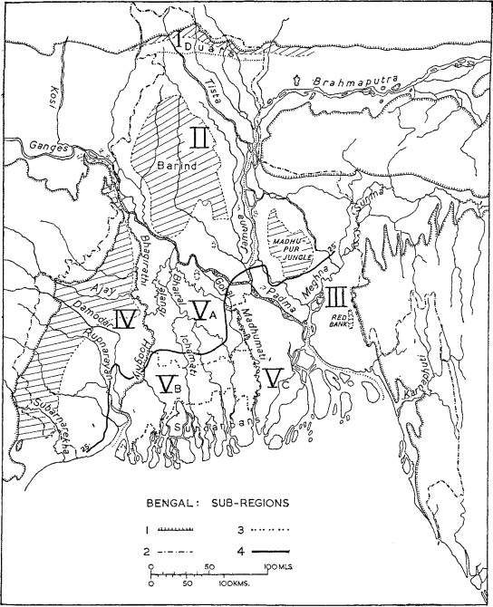

# The Bengal Delta

* + The Bengal delta comprised of sediment carried by the great **rivers-Brahmaputra, Jamuna, Ganga and Meghna-** is one of the largest deltas in the world.
  + Among these rivers the first two originated from the Himalayas and the last one from the hills of Shillong and Meghalaya.
  + They carry the maximum sediment load, amounting more than one billion tons every year.
  + Nearly 80% of which is dispatched during the monsoon months - June, July, August and September.

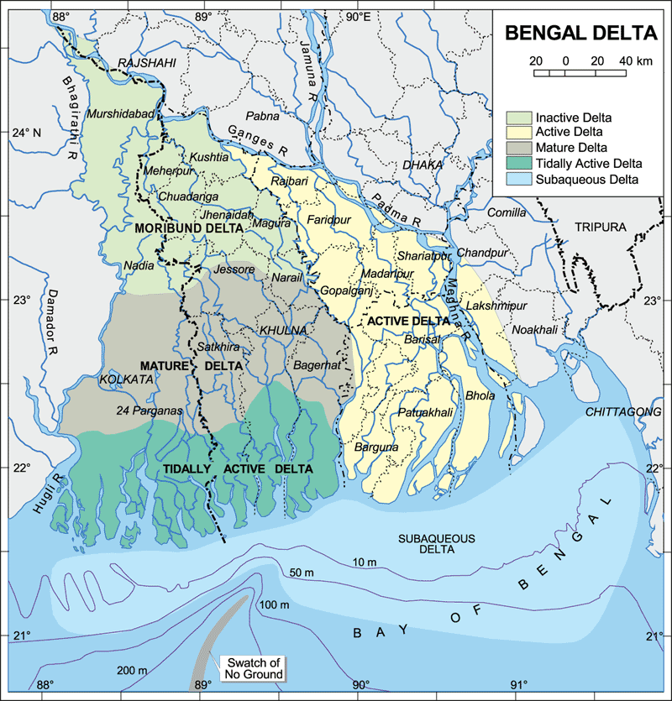

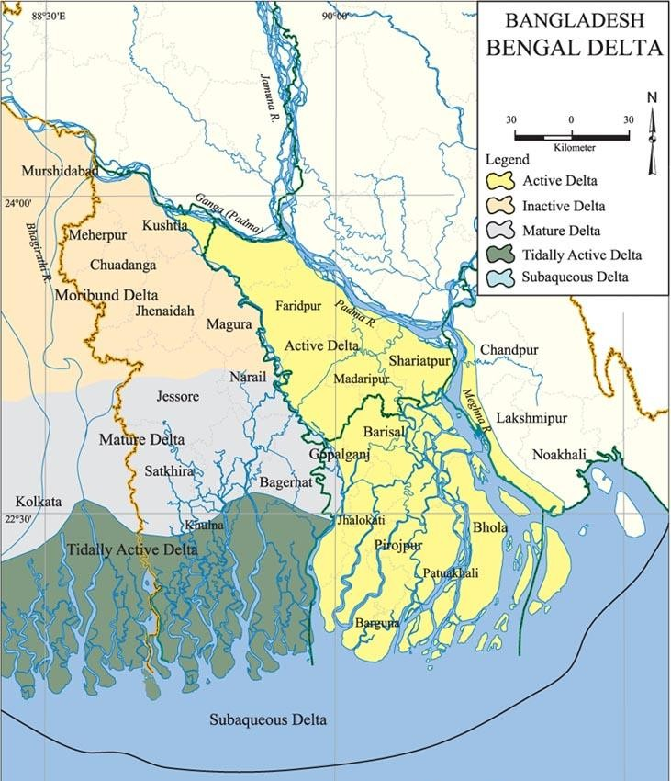

## Major Rivers of Bangladesh

* **The Brahmaputra** also known as the *Lauhitya*, popularly known as the Brahmaputra, originated from the Manasaravar located in the northern fringe of the Himalayas, entered present day Bangladesh through the northeastern part of the Kurigram district.
* The present course of the Brahmaputra and its lower stream known as the Jamuna River
* It runs from the mountain of Tibet to Bay of Bengal for about 2850 km.
* In Bangladesh, Brahmaputra-Jamuna runs for 276 km, whereas the first one alone 69 km only

**For further reading please follow the link**

<https://en.banglapedia.org/index.php?title=Brahmaputra_River>

# The Padma

* + The eastward flow of the River Ganga
  + At present the river entered Bangladesh through the western part of the Rajshahi city and then flows southeastward.
  + The river joins with the Jamuna at Goalanda, Rajbari.
  + From here it retains the original name (Padma) and goes further southeast.
  + At Chandpur the Padma-Jamuna combined stream meets the Meghna and lost its identity as the Padma.
  + The new combined stream of the three rivers, known as the Meghna carries the large portion of water and silt to the Bay of Bengal

**For further reading please follow the link**

<https://en.banglapedia.org/index.php?title=Padma_River>

## River System

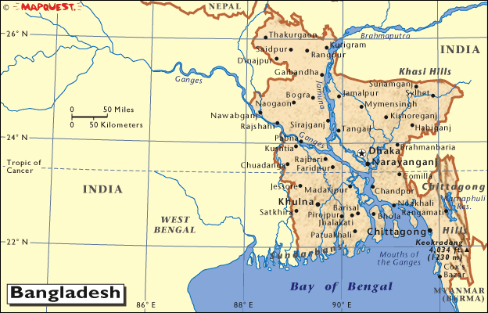

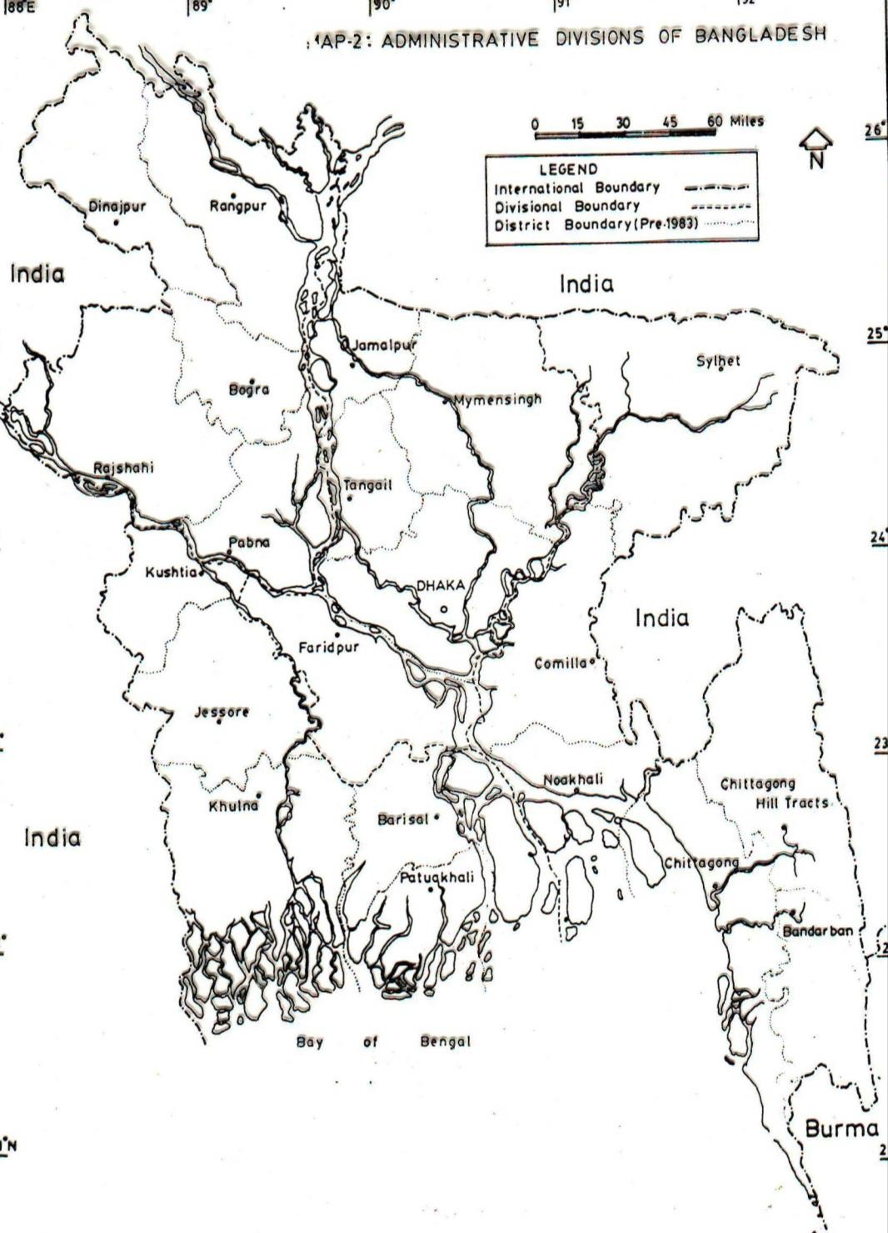

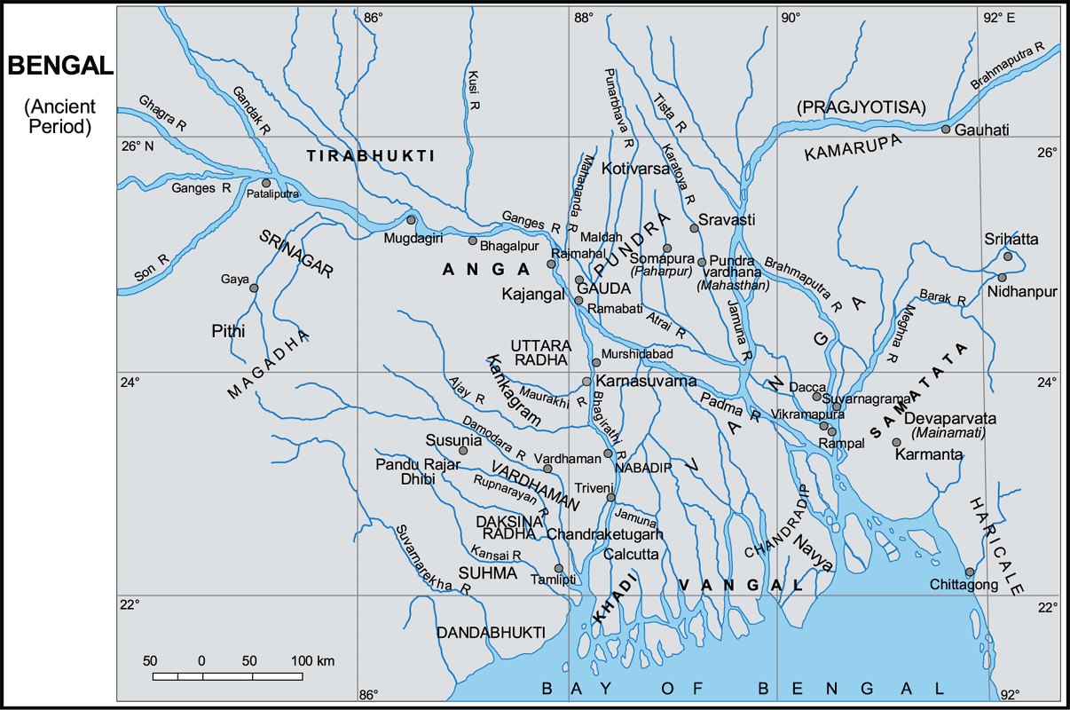

### Sundarbans

(combination of two Bengali words denote the meaning of beautiful forest)

* Situated in the southern fringe acting as a buffer zone for mixing saline water of the sea and sweet water carried by the rivers.
* This mangrove forest was declared as the World Heritage Site by UNSCO in 1997.
* It covers an area of 16,700 sq km, 60% of which is in Bangladesh (Patuakhali, Bagerhat, Khulna, Satkhira) and the rest in West Bengal

## Climate: Bangladesh

* Located in the in the monsoon zone
* *Sharariturdesha* or country of six seasons
* Rain: May/June to August/ September
* Heat and Humidity: Summer heat
* Flood: due to excessive rains:

– flash flood in *haor* area

* Natural Disasters: Earthquake, Cyclone, Thunder Storm
* Moderate Cold in winter

**For further reading please follow the link**

<https://en.banglapedia.org/index.php?title=Climate>

## Influence of Geography

* + Early civilization grew in the comparative old land with high elevation
  + Human settlements and cities were located beside the major rivers and their tributaries
  + Bengal attracted outsiders throughout its history resulting in an ethnic ‘melting pot’
* Most of the time during Ancient and medieval period Bengal remained outside the Indian Empire
* Due to location Aryan civilization came almost a thousand years later
* As a result, Pre-Aryan Culture became strong and ultimately there was a blending of these distinct cultures
* Rural Bengal: The scenic beauty with rivers and green fields
* Brick Structures (religious and secular)
* Development of Terracotta Art
* Agricultural Economy
* Bay of Bengal: Doorway to maritime world
* Trade based on Agricultural Products: Rice and fine clothes are two age old export items
* Rice and Fish Culture
* Development of Boat Industry
* Participation in Indian trade as well as global trade
* Songs, ballads, festivals centered on rivers & harvesting (*Nauka baich*, *Bhatiyali*, *Nabanna*, *Chaitrasankrati* etc)